W616 SOP1 topics

In w616 having two services
1.l26_service
2. GnssService
3. Default baud rate: 460800
1. l26_service is to communicate with the module by opening serial interface over uart and it will send the data to Gnss HAL.
Uart interface : cat /dev/ttyHS1
In adb shell use above command and check from module data is coming or not. If you are running this command in cmd data will not go to HAL. Use this command for just checking only.
2. Gnss service receive the data from l26 service through local socket rild-nmea.
Flow:
Gnss_module->l26_adr->rild_nmea->gnss_service->framework->APP
Any changes done sever will reflect in l26 binary:
Code path for l26 service:
data8/mkapadi/w11/aosp-caf/vendor/quectel/server
Path to push l26 binary in hw:
l26_service /vendor/bin
Path to push Gnss libraries in hw:
android.hardware.gnss@2.0-impl-ql.so /vendor/lib64/hw data sending from HAL through call back to framework.
Source code path:
/data8/mkapadi/w11/aosp-caf/vendor/quectel/gps/2.0
gps.default.so /vendor/lib64/hw What ever data is receiving from module to HAL for parsing.
Source code path:
/data8/mkapadi/w11/aosp-caf/vendor/quectel/gps/quectel/src
For Writing speed and gear info to module for DR:
Source code path:
data8/mkapadi/w11/aospcaf/vendor/quectel/gps/2.0$Vehicle_Property.cpp
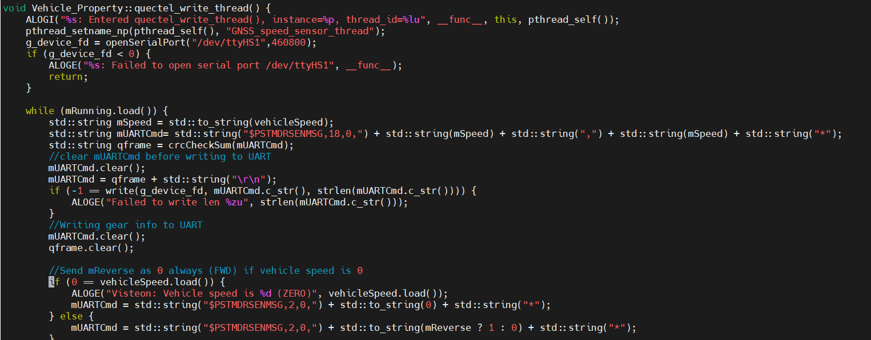
Enabling All the required configuration enble in debug array as well in l26 module in server/main.c
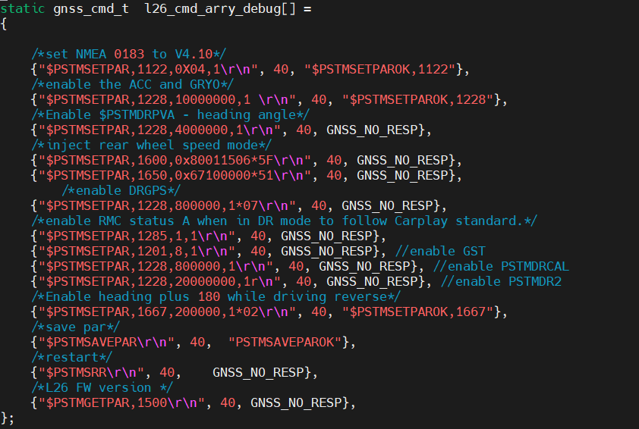
To enable message coming from module in l26 service to reach to GNSS HAL in server/ ql-resolve.c
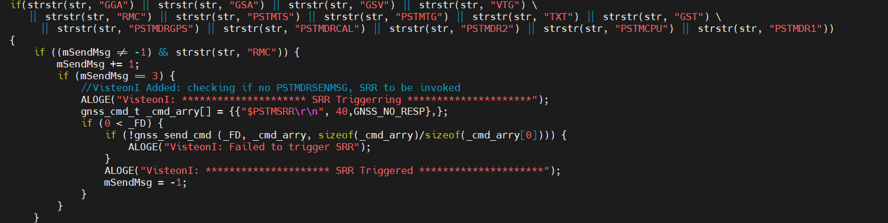
Complete NMEA receiving in gnss HAL in quectel/gps/quectel/src$ vi ql-nmea.c
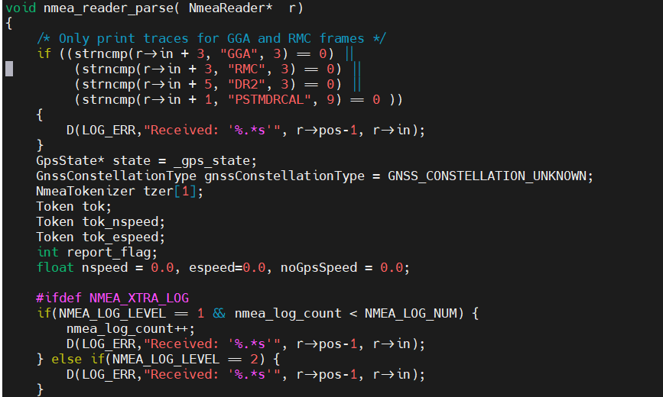
FW flashing in Quectel module:
Push the L26ADRNR12A03_BETA0925_UPG.bin to /data/l26_log/GNSS and /data/l26_log
Comment this part in Vehicle_property.cpp and push the binary Why because L26 service is opening the uart for reading the data and In Vehicle_property.cpp opening the uart for writing the speed and gear over uart baud rate fetching will fail with multiple serial port opening and flashing will fail.
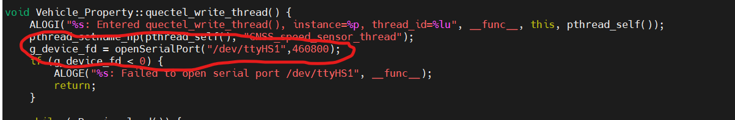
Enter the command in adb shell and reboot the HW:
echo '$PSTMFWUPGRADE\r\n' > /dev/ttyHS1
Grep for l26 logcat -b all | grep -ie l26 will see the flashing status
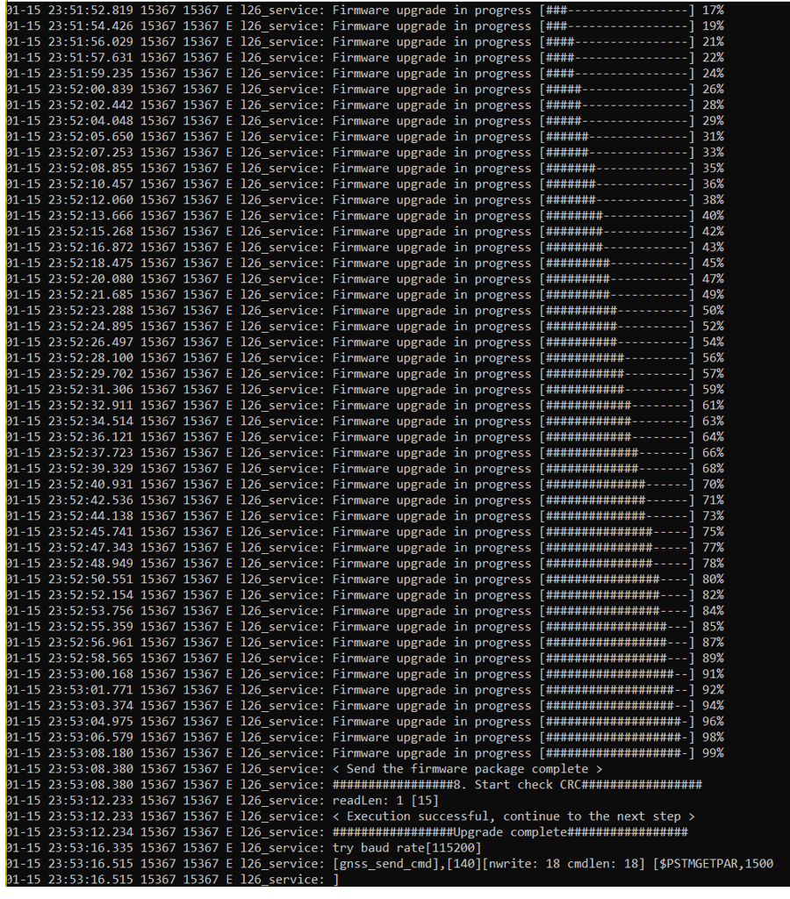
Flashing success and fw version:
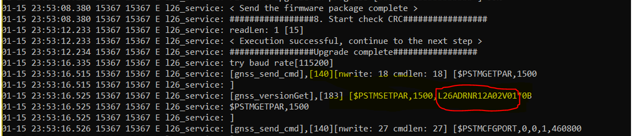
Enabling GNSS logs:
#define GPSINFO_FILE "/data/vstgloballogcontrol/GNSS/l26_gps.log -- gnss log file
Enable below prints to get l26 GNSS logs and push the binary and GNSS in vst logger application and do battery cycle.
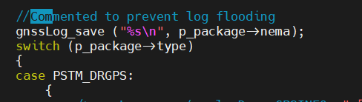
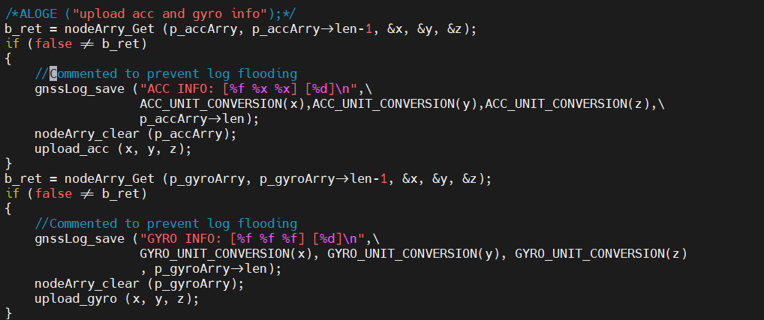
For DR checking DR is calibrated or not:
$PSTMDRCAL,1,1,1,1,ff,1,1,F*04 :
F – full N -No L – Light
$PSTMDR2,CC,AA,1,0,1,0.06,-0.35,1,2.000,0*0E : 5th segment '1' means system entered into Calibration
To clear the DR calibration:
==========================
Note: DR will not erase with battery cycle in l26 ADR give this commands in adb shell to delete calaibartion.
echo '$PSTMGPSSUSPEND*14\r\n' > /dev/ttyHS1
echo '$PSTMNVMITEMINV,80,1*32\r\n' > /dev/ttyHS1
echo '$PSTMNVMITEMINV,81,1*33\r\n' > /dev/ttyHS1
echo '$PSTMSRR*49 \r\n' > /dev/ttyHS1
FW flashing alternate method:
==========================
Another way of FW flashing have different document but need to disable uart communication in Vehicle_property.cpp

